Practical 13

Part A
1) | Generic containers: a generic Box<T> with get/set and a Pair<A,B>; use them with different types to show type safety without casts, and write a generic method that returns the first element of any array.
 | ContainerDemo.java
Code | class Box<T> { private T value;  void set(T value) { this.value = value; } T get() { return value; }  }  class Pair<A,B> {  private A first; private B second;  Pair(A first, B second) { this.first = first; this.second = second; }  A getFirst() { return first; }  B getSecond() { return second; }  }  public class ContainerDemo { static <T> T first(T[] values) {  if (values.length == 0) { throw new IllegalArgumentException("Empty array"); } return values[0];  }  public static void main(String[] args) {  Box<String> names = new Box<>(); names.set("Tej"); Box<Integer> marks = new Box<>(); marks.set(90); Pair<String,Integer> pair = new Pair<>(names.get(), marks.get()); System.out.println(pair.getFirst() + " " + pair.getSecond()); System.out.println(first(new String[]{"Java","Python"})); System.out.println(first(new Integer[]{10,20}));  }  }
Output | 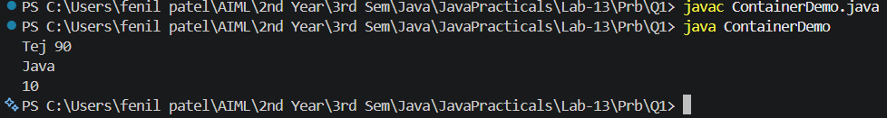

2) | Bounded stats: a generic method <N extends Number> double average(N[] values) that works for Integer[], Double[] and Long[]; note why it refuses non-Number types.
 | Stats.java
Code | public class Stats {  static <N extends Number> double average(N[] values) {  if (values.length == 0) { throw new IllegalArgumentException("Empty array"); } double sum = 0;  for (N n : values) { sum += n.doubleValue(); } return sum / values.length;  }  public static void main(String[] args) { System.out.println(average(new Integer[]{10,20,30})); System.out.println(average(new Double[]{1.5,2.5})); System.out.println(average(new Long[]{100L,200L}));  }  }

 | String[] is rejected at compile time because String does not extend Number.
Output | 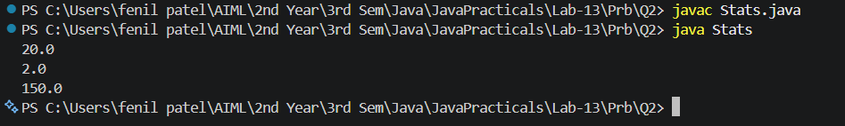

3) | (For Advanced Learners – home) Implement a small generic container of your choice (e.g. a stack) backed by an array, reuse it for two different types, and handle the empty case sensibly.
 | StackDemo.java
Code | import java.util.EmptyStackException; class Stack<T> {  private Object[] data; private int size;  Stack(int capacity) { data = new Object[capacity]; } void push(T item) {  if (size == data.length) { throw new IllegalStateException("Stack full"); } data[size++] = item;  }  @SuppressWarnings("unchecked") T pop() {  if (size == 0) { throw new EmptyStackException(); }  T item = (T) data[--size]; data[size] = null; return item;  }  }  public class StackDemo {  public static void main(String[] args) {  Stack<Integer> numbers = new Stack<>(3); numbers.push(10); numbers.push(20); Stack<String> names = new Stack<>(2); names.push("Tej"); System.out.println(numbers.pop()); System.out.println(names.pop());  try { names.pop(); }  catch (EmptyStackException e) { System.out.println("Stack empty"); }  }  }
Output | 